**Dashboard Design**

| Date | 12 oct 2025 |
| --- | --- |
| Team ID | SWUID20250216152 |
| Project Name | Predicting Plant Growth milestones with environmental and management factors |
| Maximum Marks | 5 Marks |

### Dashboard Overview

The dashboard titled **“Plant Growth Milestone: Factors and Insights”** visualizes the relationship between environmental and management parameters — including soil type, water frequency, temperature, humidity, and fertilizer — and their collective impact on plant growth.

It provides a single, interactive view that allows agricultural analysts and greenhouse managers to explore which conditions yield optimal growth outcomes.

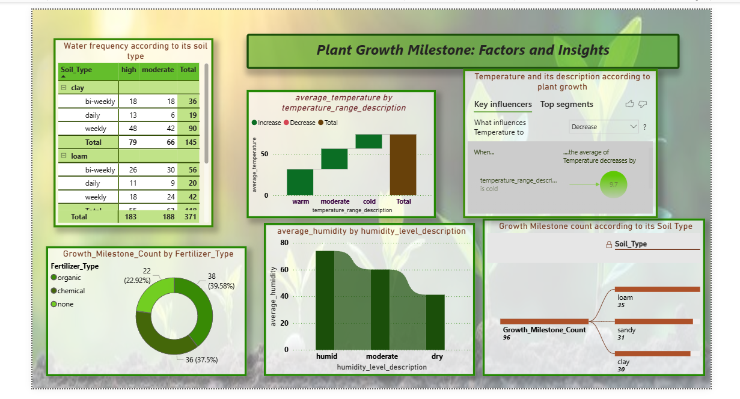

### 

### Dashboard Components and Insights

1. **Water Frequency According to Its Soil Type**

· Displays how different watering schedules (daily, weekly, bi-weekly) impact plant growth across soil types.

· **Insight:** Loam soil with high water frequency results in the highest total water frequency, indicating that loam soil may require or benefit from more frequent watering compared to sandy and clay soils.

2. **Average Temperature by Temperature Range Description**

· Visualizes the relationship between temperature ranges (warm, moderate, cold) and average temperature.

· **Insight:** Moderate temperature ranges have the highest average temperature increase, suggesting that plants in this range experience the most growth.

3. **Temperature Description According to Plant Growth (Key Influencers Visual)**

· Explains which temperature conditions influence plant growth performance the most.

· **Insight:** Cold temperature range decreases plant growth, highlighting the negative impact of cold temperatures on plant development.

· Warm temperature range increases plant growth, highlighting the positive impact of warm temperatures on plant development.

4. **Growth Milestone Count by Fertilizer Type**

· A donut chart showing growth distribution across different fertilizer types.

· **Insight:** Chemical fertilizers account for the highest growth milestone count, indicating their effectiveness in promoting plant growth milestones compared to organic fertilizers or no fertilizer.

5. **Average Humidity by Humidity Level Description**

· Demonstrates how humidity ranges (humid, moderate, dry) affect growth.

· **Insight:** Humid conditions lead to the highest average humidity, emphasizing the importance of maintaining high humidity levels for optimal plant growth.

6. **Growth Milestone Count According to Soil Type**

· A horizontal bar chart comparing total milestones by soil type.

· **Insight:** Loam soil has the highest growth milestone count, suggesting it is the most conducive soil type for achieving plant growth milestones.

### Key Highlights

· The **moderate temperature (20–30°C)** and **humid environment (50–70%)** provide the best conditions for plant growth.

· **Loam soil with daily watering** consistently achieves the highest growth milestones.

· **Chemical fertilizers** offer marginally higher yields but can be replaced with **organic alternatives** for sustainable results.

· The **Key Influencer visual** enhances interpretability by pinpointing temperature as a major factor in growth fluctuations.

### Design Evaluation

· **Color & Theme:** Uses green and earthy tones symbolizing agriculture and sustainability.

· **Layout:** Clean grid with section borders and subtle backgrounds for readability.

· **Interactivity:** All visuals are cross-filtered, enabling instant comparative analysis.

· **Clarity:** Each section is labeled clearly, allowing users to identify insights quickly.

### Summary

The **Plant Growth Milestone Dashboard** provides actionable insights for optimizing plant growth by integrating environmental and management data. Through intuitive visuals and smart interactivity, it helps decision-makers adopt **data-driven agricultural strategies** for consistent and sustainable crop development.